**PLANNING SECURE CONSUMPTION:**

**FOOD SAFETY USING BLOCKCHAIN**

A Term Paper / Project

Report

Submitted in the partial fulfillment of the requirements for

the award of the degree of

**Bachelor of Technology**

**in**

**Department of COMPUTER SCIENCE AND**

**ENGINEERING**

**by**

A.Manogna Srinaga V L S (170031532)

R.Nachiketh (170031105)

V.Vivek (170031490)

R.Arun Kumar (170031578)

**under the supervision of**

**Dr.A V Praveen Krishna**

**Assoc.Professor**



**Department of Computer Science And Engineering**

K L E F, Green Fields,

Vaddeswaram- 522502, Guntur(Dist), Andhra Pradesh, India.

December, 2020

**K L E F**

**DEPT OF COMPUTER SCIENCE AND ENGINEERING**

**(DST-FIST Sponsored Department)**



**Declaration**

The Project Report entitled “Planning secure consumption: Food safety using Blockchain” is a record of bonafide work of Atkuru Manogna Srinaga(170031532), Regonda Arun Kumar(170031578), Rapelliwar Nachiketh(170031105) and Velga Vivek Vardhan(170031490) submitted in partial fulfillment for the award of B.Tech in Computer Science and Engineering to the K L (Deemed to be University). The results embodied in this report have not been copied from any other departments/University/institutes..

A.Manogna Srinaga V L S (170031532)

R.Nachiketh (170031105)

V.Vivek (170031490)

R.Arun Kumar (170031578)

**K L E F**

**DEPT OF COMPUTER SCIENCE AND ENGINEERING**

**(DST-FIST Sponsored Department)**



**Certificate**

This is to certify that the project report entitled “Planning secure consumption: Food safety using Blockchain” is being submitted by A.Manogna Srinaga V L S (170031532), R.Nachiketh (170031105), V.Vivek (170031490), R.Arun Kumar (170031578) submitted in partial fulfillment for the award of B.Tech in Computer Science And Engineering to the K L University is a record of bonafide work carried out under our guidance and supervision.

The results embodied in this report have not been copied from any other departments/ University/Institute.

**Signature of the Co-Supervisor Signature of the Supervisor**

**Name and Designation**  Dr. A V Praveen Krishna

Assoc.Professor

**Signature of the HOD Signature of the External Examiner**

**Mr.Hari Kiran Vege**

**Acknowledgement**

The success of this project would not have been possible without the timely help and guidance of our advisor, **Dr A V Praveen Krishna**. We express our gratitude for his knowledge and guidance which motivated us to achieve our collective goals. He has constantly been a source of motivation and support. The time we have spent working under his supervision has taught us critical thinking and sharpened our research abilities.

We thank **Mr Hari Kiran Vege**, Head of the Department for computer science and Engineering for providing us with adequate facilities, ways, and means through which we were able to complete this Research work.

We are happy to express our deep sense of gratitude to the honorable Vice-Chancellor **Dr L. S. S. Reddy**, K L (Deemed to be University) for providing us the necessary encouragement to carry out this project.

In addition, we thank all the Teaching and Non-Teaching Staff of our department including our classmates and friends for their support in the completion of our work.

A.Manogna Srinaga V L S (170031532)

R.Nachiketh (170031105)

V.Vivek (170031490)

R.Arun Kumar (170031578)

**Abstract**

Agriculture is the foremost form of sustenance for all living beings on the planet. Food supply chain management is the flow of agricultural commodities from farms, harvesters, processing, distributing, retail and finally consumers. It is a sequence that starts from food production and extends till final consumption. The existing traceability of the food supply chain isn’t entirely reliable and is prone to contamination. The authenticity of each stakeholder cannot be checked manually as it is a time-taking and laborious process. Instead of trusting a centralized source, a transparent and decentralized process can be adapted through Blockchain Technology to trace the food on our plate back to its source. Blockchain is a peer-to-peer network that does not depend on a central authority and helps keep the data in the ledger tamper-proof. It would be an effortless way to prevent serious health risks from fraudulent activities and be versed in the origin, transport and sale of the products that consumers buy from stakeholders; and make sure that the transactions of both food and money are accessible to all stakeholders. In this paper, we propose safe tracing using Blockchain Technology & Smart Contracts which would not only make it transparent but also tamper-proof. The information of each transaction in the supply chain is recorded in immutable ledger and safety is verified before proceeding to the next block, through smart contracts which are implemented in Ethereum. Through the proposed solution, a long-lasting trust is established among the consumers and the stakeholders to make it reliable, contamination-free and traceable. The entire supply chain, right from the fields to the kitchen, will be closely monitored which leaves room for no mistakes.

###### Table of Contents

**Chapter Title Page**

|  |  |  |
| --- | --- | --- |
|  | Title Page | 1 |
|  | Acknowledgements | 6 |
|  | Abstract | 7 |
|  | Table of Contents | 8 |
|  | List of figures | 10 |
|  | List of tables | 11 |
|  |  |  |
| 1 | Introduction | 12 |
|  | 1.1 Food Supply Chain Management(FSCM) | 13 |
|  | 1.2 Blockchain | 14 |
|  | 1.3 MetaMask | 15 |
|  | 1.4 Smart contracts | 15 |
|  | 1.5 Ganache software | 16 |
|  | 1.6 Structure of the Thesis | 17 |
| 2 | Literature Review | 18 |
|  | 2.1 Related research and software applications | 18 |
|  | 2.2 Trends in blockchain and food safety | 19 |
|  | 2.3 Relevance to our research | 21 |

1. Theoretical Analysis 22
   1. Blockchain as a service for traceability 22
   2. Roles involved in traceability 22
2. Experimental investigation 25

4.1. Working and implementation 25

4.2. Front-end pages 25

4.3. Using metamask and ganache 38

4.4. Validation and authentication 39

5 Experimental results 43

5.1. Farmer Registration 43

5.2. Farmer Validation 44

5.3. Product Grading 45

5.4. Consumer query request 46

6 Discussion of results 47

6.1. Drawbacks and recommendations 49

7 Summary 50

7.1. Result of our project 50

7.2. How it helps in real-time applications 50

7.3. How can it be used? 51

7.4. Conclusion 51

8 References 52

**LIST OF FIGURES**

**Name of the figure Page No.**

Fig 1.1 Flow of supply and finance in supply chain 14

Fig 3.1 Roles and components of proposed model 22

Fig 3.2 Smart Contract dApp implementation 24

Fig 4.1 Structure of BlockChain 25

Fig 4.2 Metamask pop-up 39

Fig 5.1 Farmer registration 43

Fig 5.2 Logistics verification 44

Fig 5.3 Product details 45

Fig 5.4 Consumer 46

Fig 6.1 Flow control of supply chain using blockchain 47

Fig 6.2 Experimental Result 48

**List of Tables**

**Table Name Page**

Table 2.1 Applications related to blockchain supply chain tracing 19

**Chapter 1:**

**1.Introduction:**

Since the past decade, food safety has grown in prominence and the significance placed on the food products has risen proportionally. The end-consumer is completely unaware of the products that they are purchasing in the market which in the past have resulted in several fraudulent activities, food scams and even contamination. The pandemic has made us more vigilant of what we are eating and where the products originated from. Due to inadequate safety measures, there have been several drawbacks.

The W.H.O estimated around 420,000 deaths due to food-borne diseases every year. Even though most diseases are curable they do tend to have long term effects and eventually lead to cancer or neurological disorders. These diseases have a much higher impact on people with lower immunity and significantly vulnerable state of health. The risks are especially higher in younger children whose immune systems are still developing, pregnant women can be in severe danger as they would lead to premature labour, infections; It can also have fatal effects on the elderly. These contaminants can occur in many forms- during the process of farming, harvesting, transportation from fields to storage, lack of proper storage facilities or temperature variances, retail stores even before it reaches the consumer. This has made the entire process of tracing more difficult and complicated as it is difficult to narrow down the exact whereabouts of the contamination.

This has led to far more damage than just on a personal level. There are economic and financial losses that have led to financial ruin and loss of business. It has an impact on companies and in turn employees who lose their job or a significant decrease in wages due to the sales reduction. Everyone has to play a role in the food safety area among industries, government, institutions, academic professionals and employees.

1. **The existing system-**

The existing food supply chain is traced using a centralized system but these could result in fraud, contamination, tampering and false information as it is entirely based on a trusted system that depends on an authoritative third party. This kind of system can easily be tampered with and collapse as it is vulnerable to any form of limitations.

A distributed tracing system being used is fairly efficient to map the entire chain of food but it also has yet to maintain privacy and that issue hasn't been solved in this system.

1. **The proposed system-**

Almost a decade ago, the publication of a cashless transaction system by anonymous author S Nakamoto revolutionized the way the entire world looked at cashless transactions and introduced a unique and decentralized method where trust doesn't need to be placed on middle parties. The first problem dealt is double-spending through a public ledger where all transactions are transparent where the payment was then verified by a group of nodes.

In this paper, we will explore how to trace agricultural supply chains with the help of blockchain which guarantees tamper-proof mechanisms that prevent fraudulent activities. This work we use a private blockchain where all participants need permission or consent to join the network. Only the participants in the network can access the blockchain. This way the sensitive data is protected and within the safety of a network.

**1.1. Food Chain Management (FCM)**

• The food production chain is responsible for the flow of agricultural products from farms to consumers. The process of planting crops, harvesting, yielding, transportation, storage and retail is described in this supply chain. It is an important process that traces from farms to kitchen tables.

• The first step of this network is cultivation of crops that have high demand in the market and the ones that the clients covet more often. The demand is met through this step.

• After harvesting by following safe methods of eradication of pests and diseases, these cultivated crops are transported to other stages of supply.

• Each step of the chain needs to be intervened by humans or other validators and administrators who are responsible.

• Because as one step of the chain is affected then the rest of the steps would be affected.

**Background**

In the entirety of the supply chain, the cultivated food travels from farmer to consumer in stages of cultivation, distributing and later sending them to retail, and finally end consumer; Similarly, cash that the clients pay for products travels in a bi-directinal way and again in reverse.

Therefore, this bi-directional mechanism links farmers and the consumers that purchase the product and via a way of means of those units below the figure shows a representation.

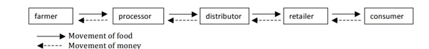

Fig 1.1 Flow of supply and finance in supply chain

The above figure shows movements of products and funds in a simple food chain.

**1.2.Blockchain**

Blockchain is a ledger of transparent transactions that store information in a manner that deems it tough or not possible to change the system.It is a virtual system that prevents duplication or any fraud in transactions through the network of systems in blockchain. Every block withinside the chain carries some of the transactions, whenever a brand new process happens in the blockchain, details related to this transaction is stored in the block of the ledger in the network.  
Blockchain, occasionally called Distributed Ledger Technology (DLT)

This paper focuses on a private blockchain called ganache that uses a virtual environment to set up initial 10 blocks with ethers, private keys and addresses. To connect the remote ethereum nodes we use metamask which is discussed in the next subsection.

**1.3. MetaMask**

MetaMask could be used as an extension that lets us run dApps without actually participating in the Ethereum network. It permits us to use it with another Ethereum Node and run smart contracts on its Node. The password encrypts the wallets and a seed word which is stored safely by the user so it's unhackable. The wallet is only accessible after entering the password which makes it secure.

MetaMask manages your Ethereum wallet, which includes your Ethers (or money), and permits you to ship and acquire Ethers via a dApp of interest.

**1.4. Smart contracts**

Smart contract is a computer program that uses blockchain technology if the given conditions are met it automatically verifies and validates and also all the saved data will be secured.

The advantages of smart contracts are:

• **Advance/Speed:** As smart contracts are digital, and automatic so, you won’t spend time processing in correcting the mistakes which have been stuffed manually.

**• Trust/Belief:** Smart contracts follows predefined rules which helps in execution of the transactions automatically and encrypted data would be transfer throughout the blocks

**• Protection:**  The transactions of blockchain are encrypted, so it makes them very hard to hack. All individual documents are hooked up to preceding, and next data on an allocated ledger, so to change a single record the whole chain needs to be modified.

**1.4.1. Working on smart contracts.**

Smart contracts work under the code which was written on a blockchain by the following statements if / when. .then. A network of computer systems executes the movements when predetermined situations were met and verified. The blockchain is then up to date when the transaction is completed.

For example, Y person wants to buy something from an X person, so, he/she places an order through an escrow account. X person will use Z person to ship the product to Y. When Y person receives the product, the cash which was held in escrow will be released to an X and Z person. If Y person doesn’t get the product in the given time T, the cash which was held in escrow account will be returned.

**1.5. Ganache software**

Ganache is a personal blockchain for rapid Ethereum and Corda dispensed software improvement. You can use Ganache throughout the whole improvement cycle; allowing you to develop, deploy, and take a look at your dApps in a secure and deterministic environment.

**1.6. Structure of the thesis**

This section briefly explains the outline of the complete research paper. Eight chapters are included in this thesis. Chapter 1 is about the introduction to the food supply chain, blockchain, limitations etc. Chapter 2 deals with the Literature reviews section which explains the work done by the different authors, researchers related to this thesis work and it tells about the overall studies of previous research. Chapter 3 and 4 deals with the theoretical analysis and experimental result. Chapter 5 and 6 deals with the results and discussions of this thesis. Finally Chapter 7 and 8 deals with the Conclusions and future recommendations through this study.

**Chapter 2:**

**2. Literature Analysis-**

In recent times, Blockchain technology is being used increasingly along with IoT and cloud computing methods in food tracing systems to help make efficient services to the agricultural industry.

**2.1. Related research and software applications**

Several industries are trying to implement a contamination-free system to reassure their customers about the products, as more and more consumers are aware of the detrimental effects of food contamination and are actively trying to monitor the origin of their food instead of blindly trusting an organization to do what’s best for them.

Applications like Walmart traceability pilot have set out to trace the origin and production of pork and mango using hyperledger fabric. AgriBlock IoT traces all the IoT Sensor data in the food supply chain using platforms like Hyperledger Sawtooth and ethereum. Smart farming methods have also increased through water control systems and smart watering systems where smart agriculture scenarios for irrigation systems of plants reduce the consumption of water. The latter implemented a fuzzy logic decision system with blockchain storage for data privacy.

So far the research has addressed problems regarding the integration with a legacy system, redundancy in storage and security in all agricultural systems, storage overhead tracing using IoT, how to overcome limited scalability as blockchain consuming significant bandwidth, real-time monitoring, storage of customer data for KYC systems, crop breeding data storing and accessibility using IPFS and smart contract filtering systems. Some of the best contributions involve integrating EPCIS and using hybrid storage for reducing data as well as lightweight scalable blockchain. The design of a new consensus scheme has come a long way earlier than expected. Using proxy encryption technology and real-time IoT data in IPFS gives a high throughput.

|  |  |  |  |
| --- | --- | --- | --- |
| **Application** | **Description** | **Function** | **Platform** |
| Transparent path | Displays the supply chain from farm to distributors | Real-time tracing | Decentralized blockchain app |
| IBM Food trust | Measuring food safety and freshness | Transparent tracing | Hyperledger fabric |
| Ripe.io | Automated farming processes | Supply chain tracking | Blockchain IoT devices |
| Greenfence | Authenticating food chain-of-custody | Tracing and messaging system | Hyperledger fabric |
| Hungry Coin | Trading traceability tokens | Tracking and transferring | Hyperledger fabric |
| IBM Italia | Tracing the origin and product quality | Supply chain tracing | DApp blockchain |
| Nestle | Tracing milk from farms | Transparent tracing | Ethereum |
| Walmart traceability pilot | tracing the origin of pork and mango | Traceability | hyperledger fabric |
| OriginChain | Tracing the origin of food products | Traceability | Hyperledger sawtooth |

Table 2.1 Applications related to blockchain food supply chain tracing

**2.2. Trends in blockchain and food safety**

The trend observed in agricultural applications is that the transaction throughput for hyperledger and hyperledger sawtooth is high and Quorum is medium. Several smart contract languages use solidity, java, javascript, GOLANG and python. This helps in cryptographic operations, data broadcasting and data collection, verification. Privacy, Authentication and flexibility are achieved through smart contracts. Whereas blockchain helps achieve decentralization, traceability and integrity. Each block is checked by a consensus of people, authenticated using hash-based data by government supervisors and the details are then added to the block. Food Science research Management supports functional food research data using hyperledger fabric. Plastic bank- An innovative land cleaning mechanism for reducing environmental impact also uses blockchain to gather plastic.

In the recent 5 years, from 2016 to 2020, there has been a significant increase in research and publications regarding food supply traceability through the blockchain domain. The growth of literature advocates the fact that investing in food safety would help other practitioners, researchers and consumers alike.

Researchers who have published in well-renowned journals have addressed problems related to easy food tracing to achieve transparency and avoiding food famine and poisoning. They have tried to tackle the central authority elimination to make the transaction records more transparent. In order to prevent data tampering they have used ethereum blockchain along with EPCIS to ensure no confidential data is disclosed. Few papers dealt with cryptographic consensus mechanisms used in food quality. These were done with IPFD and ethereum blockchain digital flow networks.

**2.3. Relevance to our research**

After reviewing several papers related to food supply chain tracing using blockchain, we have understood the relevance of food safety and the significance of a system or an application that the consumers and other stakeholders can rely on without the doubt of fraud or contamination. The customer data must not be compromised while also maintaining a high degree of decentralization and system robustness.

**Chapter 3:**

**3. Theoretical Analysis-**

**3.1. Blockchain as a service for traceability-**

This paper blockchain as a service (BaaS) is used to host the decentralized application to trace and configure the agricultural supply chain of crops. Furthermore, Smart contracts ensure the implementation of food safety using several blockchain frameworks. In the following subsection, we explore the roles and components of the tracing process of the supply chain.

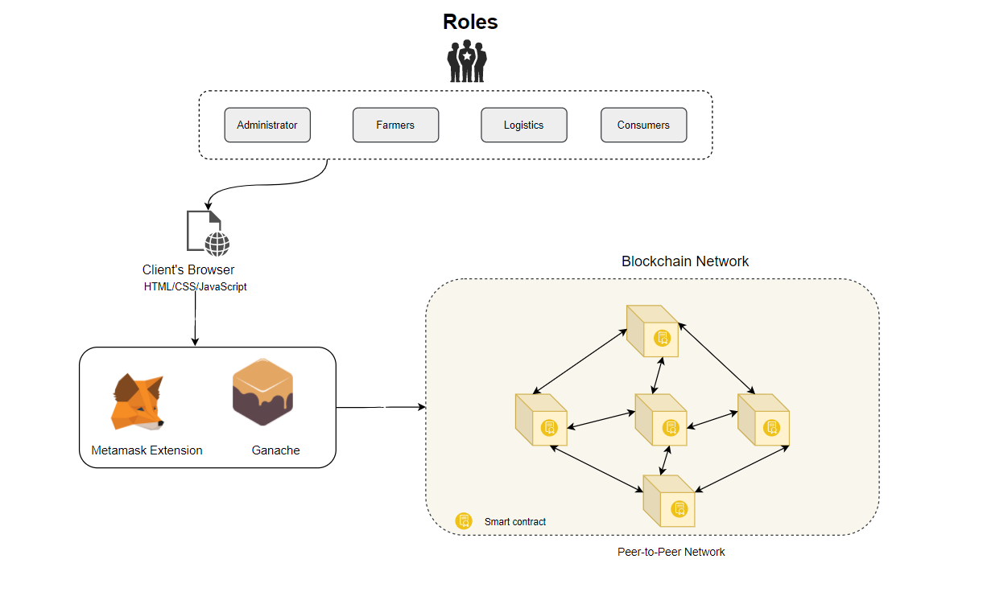

Fig 3.1 Roles and components of proposed model

**3.2. Roles involved in traceability:**

3.2.1. Legally accountable administrator/validator:

A validator helps keep the entire blockchain secure by managing the lifecycle of agriculture. Several trusted and relevant organizations help in warranting the food hazards and frauds that might occur. They can access the entire permissioned blockchain network and can also assign permissioned nodes. These administrators are responsible for the registration, configuration and approval of data through the decentralized app. They also have the authority to choose potential administrators.

3.2.2. Farmers:

The base for the entire food supply chain is farmers. A farmer is assigned an Identification Number and registered into the application by the authorized administrator and given ability to login to the application to enter the details like their ID, name, crop cultivated, temperature, the quantity of crop and expected price. Certain terms and conditions are assigned to ensure there is no scope of misleading. These details are further verified and authorized by the administrative authorities.

3.2.3. Logistics:

When a farmer submits their details, the logistics can view the entirety of the details but as mentioned above only the administrator can approve. After viewing the farmer details, the details of the product are entered such as lot no., grade of the produce (assigned by the food safety department), the production date and the expiration date. There are of course certain terms and conditions that they are accountable to and must agree upon before submitting these details.

3.2.4. Consumer:

Whoever purchases the product from retail are eligible to view the details of every step that has occurred throughout the supply chain. The entirety of the operation is visible and transparent which makes the entire process contamination-free.

**3.3. Components:**

Smart Contracts-

Creation: The supply chain is validated through smart contracts in our work. Different parts of processes are represented through smart contracts which get initialized in the block through validators. Smart contract is used primarily for supply chain creation and to handle the metamask used.

a. Storage smart contract:

In our work, we created a decentralized app(dApp) and this interacts with the smart contract which is connected through ganache. The basic structures for farmers, logistics and consumers are defined and the functions are declared to define the return values after the details are approved by the administrator. This helps the end-user to view the details of the processes involved throughout every step. For instance, whatever logistics enters into dApp is stored through a function called produce() and later returned through getproduce() function.

b. Transaction smart contract:

Each transaction when getting approved gets verified through this smart contract with the help of metamask.

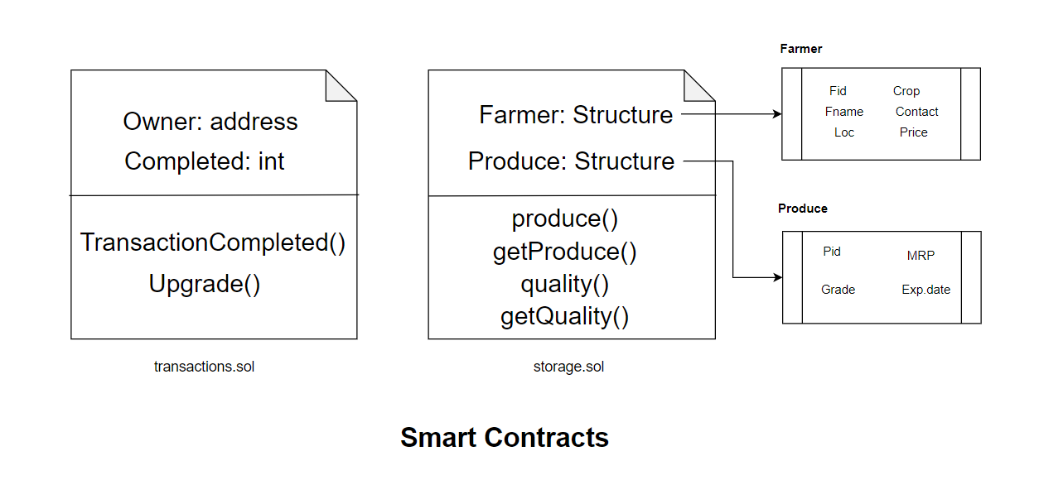

Fig 3.2 Smart Contract dApp implementation

**Chapter 4:**

**4. Experimental investigation**

**4.1. Working and implementation:**

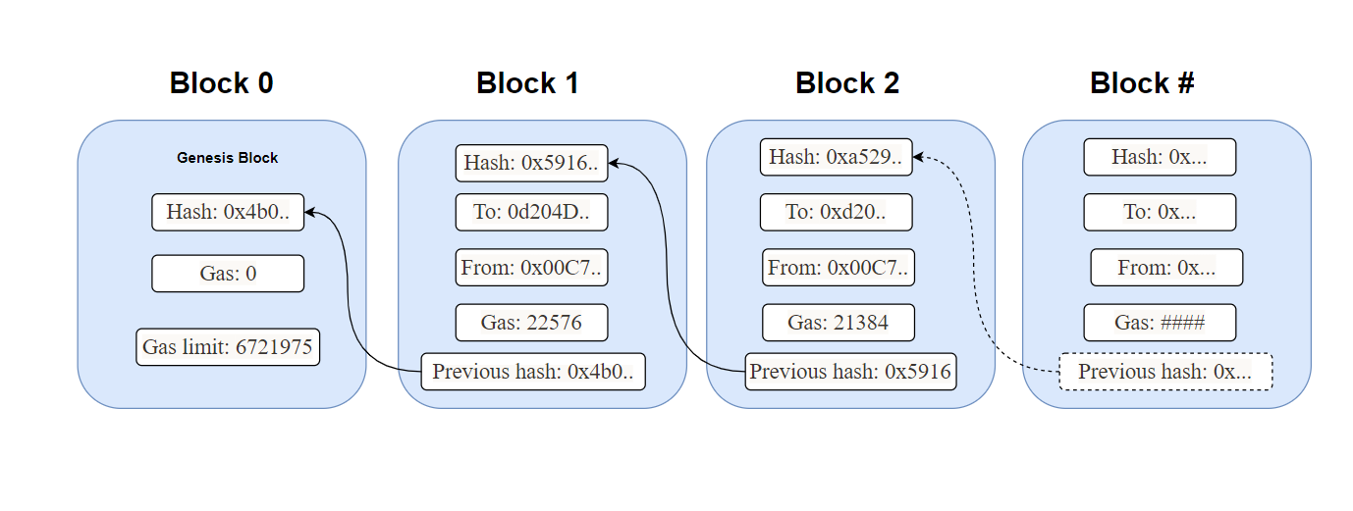

Fig 4.1 Structure of BlockChain

The front-end is connected to the back-end using smart contracts which use solidity programming language to verify blocks in the private network we have created. This is called Ganache. Ganache is responsible for storing the details of farmers, logistics and consumers into the blocks and mine them. We have kept our workspace on auto-mine mode to avoid ambiguity. The smart contracts are used to verify and store the balance ethers. In turn, they return the remaining funds and store the variables that are given as input. The storage contract is used to store all data given and later displays for the end consumer to view.

**4.2. Front-end pages**

**4.2.1. Index.html**

<html>

<head>

<title>Agricultural Blockchain</title>

<link href="./app.css" rel='stylesheet' type='text/css'>

<script src="./app.js"></script>

</head>

<body>

<h1><p style="color: black;">Agricultural Supply Chain application</p></h1>

<h4>Public Id : <span class="white"><span id="SenderBalance"></span> </h4>

<div class="btn-group" id="form-selector" align="center">

<button type="button" class="btn1 btn-selector active" id="sign-up-btn">Farmer</button>

<button type="button" class="btn1 btn-selector" id="log-in-btn">Logistics</button>

<button type="button" class="btn1 btn-selector" id="payments-btn">Consumer</button>

</div>

<div class="form" id="sign-up-form">

<h2 class="form-title">Farmer Details</h2>

<input type="text" class="input-std" id="fid" placeholder="Farmer Id">

<input type="text" class="input-std" id="fname" placeholder="Farmers Name">

<input type="text" class="input-std" id="loc" placeholder="Location">

<input type="text" class="input-std" id="crop" placeholder="Crop Name">

<input type="text" class="input-std" id="contact" placeholder="Temperature">

<input type="text" class="input-std" id="quantity" placeholder="Quantity">

<input type="text" class="input-std" id="exprice" placeholder="Expected Price">

<br><input type="checkbox" name="terms" id="terms" onchange="activateButton(this)"> I Agree Terms & Conditions <br>

<br><button type="button" class="btn-submit" id="setvalue" onclick="set()">Submit</button>

<span id="status"></span>

</div>

<div class="form" id="log-in-form">

<h2 class="form-title">Logistics</h2>

<br>

<table>

<!-- <tr><td><b><label class = "black">Farmer Id</label></td><td>:</td></b><td><span class="black" span id="getval1"></span></td></tr> -->

<input type="text" class="input-std" id="fid1" placeholder="Farmer Id">

<tr><td><b><label class = "black">Farmer Name</label></td><td>:</td></b><td><span class="black" span id="getval2"></span></td></tr>

<tr><td><b><label class = "black">Location</label></td><td>:</td></b><td><span class="black" span id="getval3"></span></td></tr>

<tr><td><b><label class = "black">Crop</label></td><td>:</td></b><td><span class="black" span id="getval4"></span></td></tr>

<tr><td><b><label class = "black">Phone</label></td><td>:</td></b><td><span class="black" span id="getval5"></span></td></tr>

<tr><td><b><label class = "black">Quantity</label></td><td>:</td></b><td><span class="black" span id="getval6"></span></td></tr>

<tr><td><b><label class = "black">Expected price</label><td>:</td></td></b><td><span class="black" span id="getval7"></span></td></tr>

</table>

<button type="button" class="btn-submit" id="getvalue" onclick="get();">Get Value</button>

<br><br>

<button type="button" align ="center" font="20px">Approve Details</button>

<span id="status"></span>

</div>

<div class="form" id="approve-form">

<h2 class="form-title">Product Details</h2>

<input type="text" class="input-std" id="lotno" placeholder="Lot Number">

<input type="text" class="input-std" id="grade" placeholder="Grade">

<input type="text" class="input-std" id="mrp" placeholder="MRP">

<input type="text" class="input-std" id="testdate" placeholder="Test Date">

<input type="text" class="input-std" id="expdate" placeholder="Expiry Date">

<br><input type="checkbox" name="terms" id="terms" onchange="activateButton(this)"> I Agree Terms & Conditions <br>

<button type="button" class="btn-submit" id="setvalue" onclick="setQ()">Submit</button>

</div>

<div class="form" id="payments-form">

<h2 class="form-title">Consumer</h2>

<table>

<input type="text" class="input-std" id="getfid" placeholder="Farmer Id">

<tr><td><b><label class = "black">Farmer Id</label></td><td>:</td></b><td><span class="black" span id="cgetval1"></span></td></tr>

<tr><td><b><label class = "black">Farmer Name</label></td><td>:</td></b><td><span class="black" span id="cgetval2"></span></td></tr>

<tr><td><b><label class = "black">Location</label></td><td>:</td></b><td><span class="black" span id="cgetval3"></span></td></tr>

<tr><td><b><label class = "black">Crop</label></td><td>:</td></b><td><span class="black" span id="cgetval4"></span></td></tr>

<tr><td><b><label class = "black">Phone</label></td><td>:</td></b><td><span class="black" span id="cgetval5"></span></td></tr>

<tr><td><b><label class = "black">Quantity</label></td><td>:</td></b><td><span class="black" span id="cgetval6"></span></td></tr>

<tr><td><b><label class = "black">Expected price</label><td>:</td></td></b><td><span class="black" span id="cgetval7"></span></td></tr>

<input type="text" class="input-std" id="lotnum" placeholder="Lot number">

<tr><td><b><label class = "black">Lot Number</label><td>:</td></td></b><td><span class="black" span id="cgetval8"></span></td></tr>

<tr><td><b><label class = "black">Grade</label><td>:</td></td></b><td><span class="black" span id="cgetval9"></span></td></tr>

<tr><td><b><label class = "black">MRP</label><td>:</td></td></b><td><span class="black" span id="cgetval10"></span></td></tr>

<tr><td><b><label class = "black">Test Date</label><td>:</td></td></b><td><span class="black" span id="cgetval11"></span></td></tr>

<tr><td><b><label class = "black">Expiry Date</label><td>:</td></td></b><td><span class="black" span id="cgetval12"></span></td>

</table>

<button type="button" class="btn-submit" id="getcustval" onclick="getQ();cgetQ();">Get Value</button>

</div>

<script src="./app.js"></script>

</body>

</html>

**4.2.2. app.css**

html {

width: 100%;

background-image: url("Img/farmers1.jpg");

font-family: 'HelveticaNeue-Light', Helvetica;

font-weight: 100;

-webkit-font-smoothing: antialiased;

}

body {

width: 100%;

}

.wrapper {

text-align: center;

}

.btn-group {

display: inline-block;

width: 100%;

height: 40px;

margin: 35px auto;

font-size: 21px;

line-height: 1.39;

border-radius: 9px;

position: relative;

}

.btn {

display: inline-block;

margin-bottom: 0;

font-weight: normal;

text-align: left;

cursor: none;

background-image: none;

border: 1px;

white-space: none;

padding: 7px 15px;

font-size: 15px;

line-height: 1.428571429;

border-radius: 4px;

margin-left: -5px;

}

.btn1 {

display: inline-block;

margin-bottom: 0;

font-weight: normal;

text-align: center;

cursor: pointer;

background-image: none;

border: 1px solid transparent;

white-space: nowrap;

padding: 7px 15px;

font-size: 26px;

line-height: 1.428571429;

border-radius: 4px;

margin-left: -5px;

}

.btn-selector {

color: #33333;

background-color: #ffffff;

border-color: #rrrrrr;

}

.btn-selector:hover,

.btn-selector:focus,

.btn-selector:active,

.btn-selector.active {

color: #333333;

background-color: #CFCCCC;

border-color: #adadad;

}

.btn-group .btn:focus {

outline: none;

}

.btn-group .btn:not(:first-child):not(:last-child) {

border-radius: 0;

}

.btn-group .btn:first-child:not(:last-child) {

border-bottom-right-radius: 0;

border-top-right-radius: 0;

}

.btn-group .btn:last-child:not(:first-child) {

border-bottom-left-radius: 0;

border-top-left-radius: 0;

}

/*end of btn group*/

/*form general*/

.form {

margin: 40px auto;

padding: 10px 30px 35px;

display: block;

width: 375px;

background-color: #DEDCDC;

box-shadow: 0 0 25px 0 #000;

}

.form h3 {

color: #FFFFFF;

font-size: 40px;

margin: 10px 0 20px 0;

}

.form h4 {

color: #000000;

font-size: 30px;

margin: 10px 0 20px 0;

}

.form h2 {

color: #000000;

font-size: 40px;

margin: 10px 0 20px 0;

}

.form input, .form button, .form h2 {

font-family: 'HelveticaNeue-Light', Helvetica;

font-weight: 100;

}

input[type="text"],

input[type="password"] {

display: block;

background-color: #ffffff;

border: 1px solid #cccccc;

box-shadow: inset 0 1px 1px rgba(0, 0, 0, 0.075);

font-size: 15px;

height: 30px;

padding: 4px 6px;

border-radius: 4px;

margin-bottom: 10px;

}

input[type="checkbox"], label {

display: inline-block;

float: left;

}

input:focus {

outline: none;

border: 1px solid #44C7A9;

}

.input-std {

width: 95.5%;

display: inline-block;

}

.input-half {

width: 45.9%;

float: left;

}

.input-quarter {

width: 21%;

float: left;

}

.btn-submit {

width: 100%;

font-size: 30px;

padding: 11px 19px;

border-radius: 6px;

border: 2px solid #cccccc;

cursor: pointer;

background-color: #4CAF50;

}

.btn-submit1 {

width: 100%;

font-size: 30px;

padding: 11px 19px;

border-radius: 6px;

border: 2px solid #cccccc;

cursor: pointer;

background-color: #4CAF50;

}

.btn-submit:focus {

outline: none;

}

#sign-up {

background-color: #5EB320;

}

#log-in {

background-color: #1893A3;

}

#remember-me-wrapper {

position: relative;

height: 30px;

}

#payments {

background-color: #B33030;

}

#cvc {

float: none;

}

#log-in-form, #payments-form {

display: none;

}

h1,h4{

text-align: center;

color:white;

}

.table{

text-align: center;

}

.blue {

color:blue;

}

.black {

color : black;

font-size : 18px;

}

.blockclass {

color : black;

font-size : 30px;

}

.logs {

background-color: black;

font-size: 14px;

color: white;

font-weight: bold;

padding: 10px;

border-radius: 8px;

}

.tab-content {

border-left: 2px solid #ddd;

border-right: 2px solid #ddd;

border-bottom: 1px solid #eee;

padding: 10px;

margin: 0px;

}

.nav-tabs {

margin-bottom: 0;

}

**4.2.3. package.json**

{

"name": "agrochain",

"version": "2.0.0",

"description": "",

"main": "truffle.js",

"directories": {

"test": "test"

},

"scripts": {

"dev": "lite-server",

"test": "echo \"Error: no test specified\" && exit 1"

},

"author": "",

"license": "ISC",

"devDependencies": {

"lite-server": "^2.6.1"

}

}

**4.2.4. Truffle.js**

module.exports = {

networks: {

development: {

host: "127.0.0.1",

port: 8545,

network_id: "*"

}

}

};

**4.3. Using metamask and ganache**

Ganache is connected to Metamask locally. A metamask is added as an extension to chrome and an account is created. Ganache workspace is set up with the same port number as metamask to connect them. The private key is copied to the import account in metamask and we obtain a default of 100 ethers which are used for approving details in a blockchain.

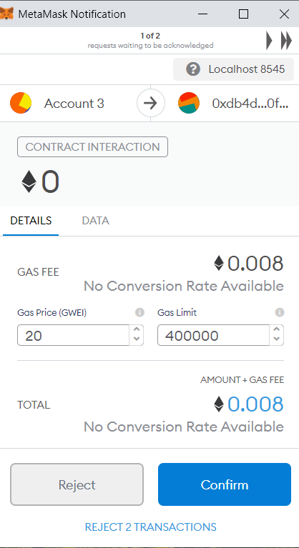

Fig 4.2 Metamask pop-up

**4.4. Validation and authentication**

Farmer page takes in all the details and ensures that the farmer has not used any harmful fertilizers and thus remains contamination-free. A metamask pop-up ensures it is used to mine blocks in the ganache and verify the details of the block. Only after confirmation, we can proceed to the logistics page which shows the authorities farmer details and then these details get approved. The product which will further be sent to storage is taken into consideration and the details are taken in and stored in ganache block and mined. The end-consumer sees all these procedures and can understand every step of the way as all the details are furnished- from the farmer to retail to consumer.

**4.4.1. Smart contracts**

**transactions.sol**

pragma solidity ^0.7.0;

contract Transactions {

address public own;

uint public completed;

modifier restricted() {

if (msg.sender == own) _;

}

constructor() public{

own = msg.sender;

}

function setCompleted (uint completed) restricted public{

completed = completed;

}

function upgrade(address new_address) restricted public{

Migrations upgraded = Migrations(new_address);

upgraded.setCompleted(completed);

}

}

**storage.sol**

pragma solidity ^0.5.0;

contract StructStorage {

uint256 public s = 1;

uint256 public c;

uint256 public t=1;

mapping (address => uint) balances;

struct farmer {

bytes fid;

bytes32 fname;

bytes32 loc;

bytes32 crop;

uint256 contact;

uint quantity;

uint exprice;

}

struct lot {

bytes lotno;

bytes grade;

uint mrp;

bytes32 testdate;

bytes32 expdate;

}

address public tester;

address owner;

mapping (bytes => farmer) f1;

farmer[] public fm;

mapping (bytes => lot) l1;

lot[] public l;

function produce(bytes memory id, bytes32 name, bytes32 loc, bytes32 cr, uint256 con, uint q, uint pr) public{

StructStorage.farmer memory fnew = farmer(id,name,loc,cr,con,q,pr);

f1[id] = fnew;

fm.push(fnew);

s++;

}

function getproduce(bytes memory j) public view returns(bytes memory,bytes32,bytes32,bytes32,uint256,uint,uint) {

return (f1[j].fid,f1[j].fname,f1[j].loc,f1[j].crop,f1[j].contact,f1[j].quantity,f1[j].exprice);

}

function quality(bytes memory ll, bytes memory g, uint256 p, bytes32 tt, bytes32 e) public{

StructStorage.lot memory lnew=lot(ll,g,p,tt,e);

l1[ll]=lnew;

l.push(lnew);

t++;

}

function getquality(bytes memory k) public view returns(bytes memory,bytes memory,uint,bytes32,bytes32) {

return(l1[k].lotno,l1[k].grade,l1[k].mrp,l1[k].testdate,l1[k].expdate);

}

}

**Chapter 5:**

**5. Experimental results**

**5.1 Farmer Registration:**

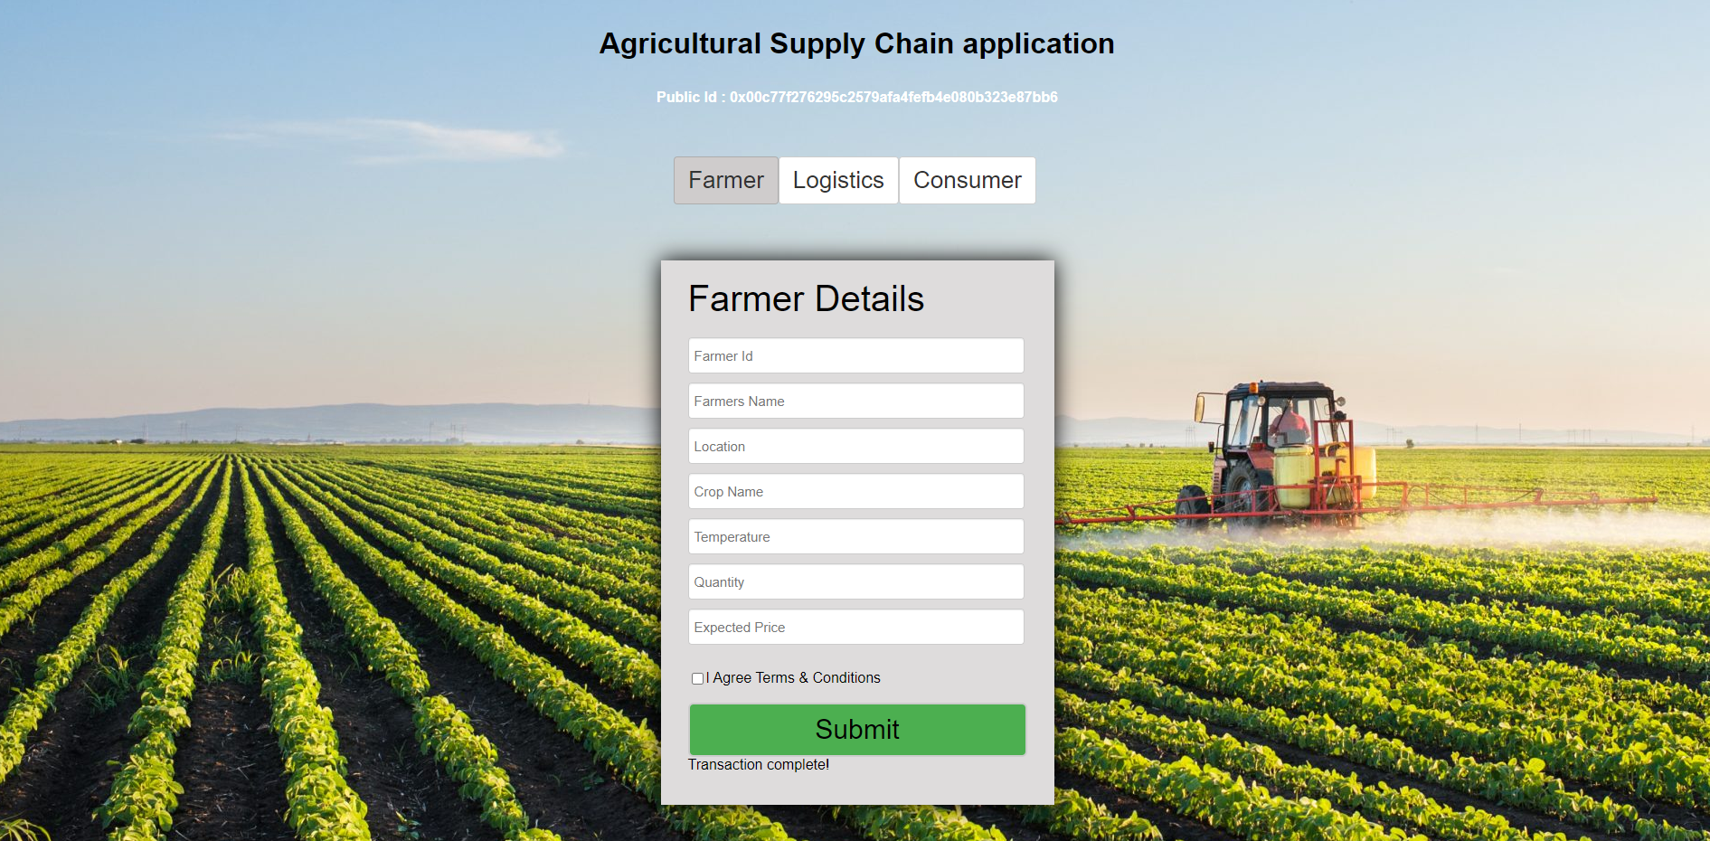

Fig 5.1 Farmer registration page

When we run the smart contract we get into a farmer registration page where the farmer needs to register. As the farmer registers through this form by giving all the details of his and his crop. His details will be sent to the logistic department, and the farmer needs to wait for approval from the logistic department for his crop so that his crops are sent for further process.

**5.2 Farmer Validation:**

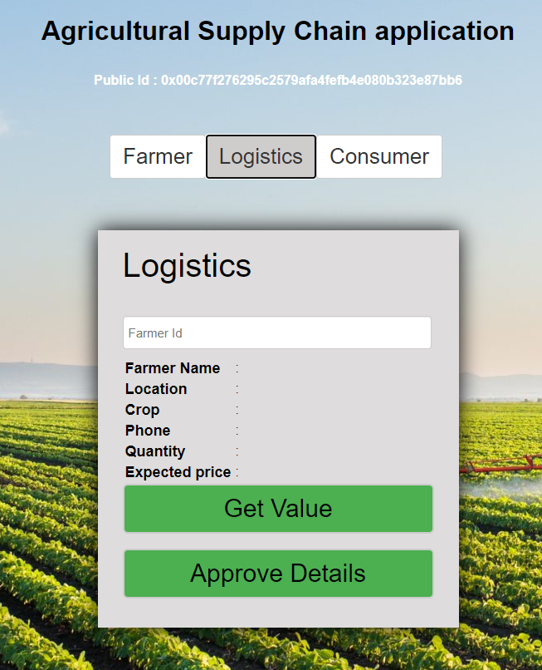

Fig 5.2 Logistics verification page

As when the farmer submits the details, the logistic department gets all the details of the farmer where they need to validate the crop and other factors. When the logistics need to validate the farmer details he needs to enter the farmer id and click on get value to retrieve all the details of the farmer. Then if everything is valid then he can approve the farmer by clicking on approve details. Then the crops will be sent to the transport area/storage area.

**5.3 Product Grading:**

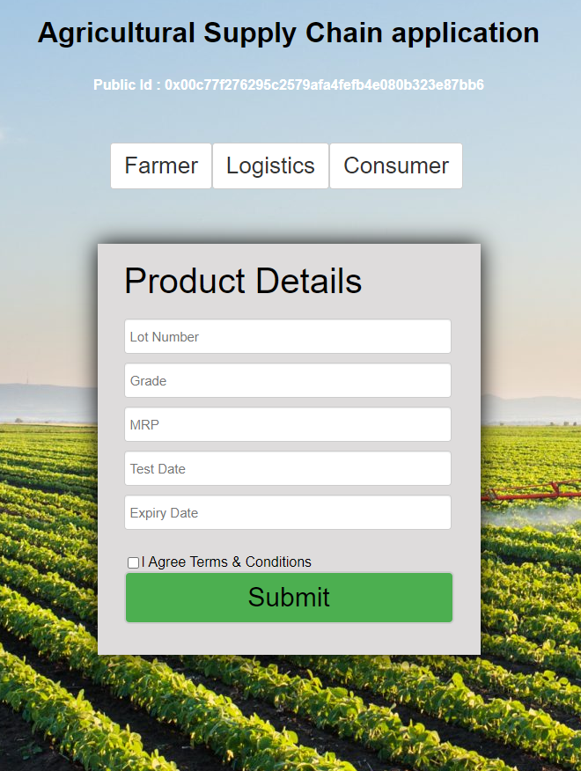

Fig 5.3 Product details page

After getting validated the crops are sent for batching. Now the logistics management needs to give the Lot Number for the crops and MRP will be fixed based on the grade of the crop and also needs to provide the test date and expiry date for that particular crop. The crop is now ready to sell so it will be transported to the shops or supermarkets and stored in proper condition.

**5.4 Consumer query request:**

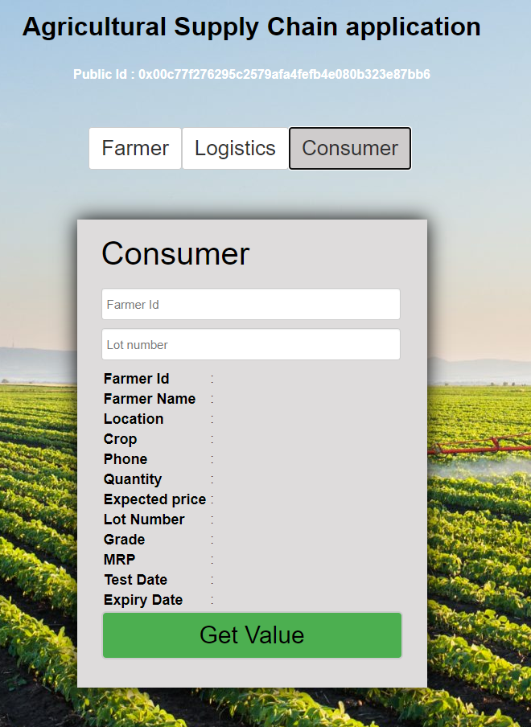

Fig 5.4 consumer view

After getting transported to shops and supermarkets it will be available for consumers to buy them. So if any consumer wants to know the origin of the crop and more detailed information about how the crop is grown he just need to enter the farmer id and lot number so that all the details will be displayed, from where the consumer can know how safe is the crop and can decide whether to buy the crop or not.

**Chapter 6:**

**6. Discussion of results:**

**6.1 Procedure flow**

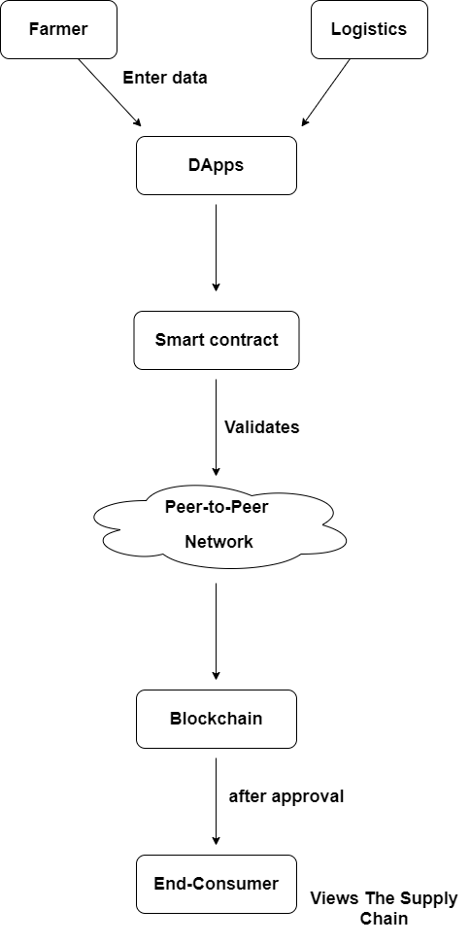

Fig 6.1 Flow control of supply chain using blockchain

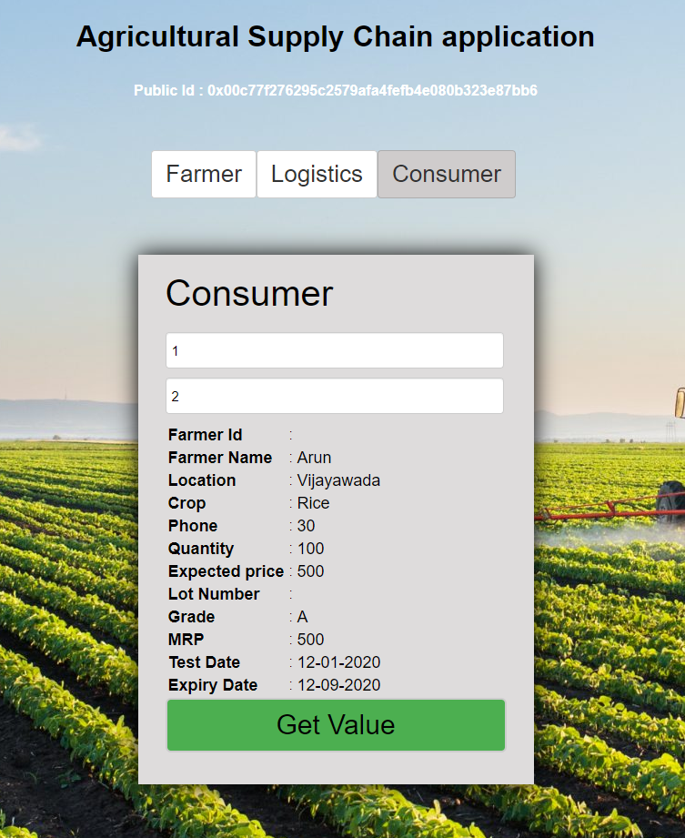

Fig 6.2 Experimental result

This is a Experimental result which is obtained using this process so through this the consumer gets all the details of the crop and its grade and manufacture date. This will help to assure the quality of the crop to the customer.

The Results obtained in this process are immutable and traceability is displayed throughout the process. The experimental results would show the details of the farmers which include farmer’s name, farmer crop, fertilizers, irrigation process, and date of crop takeout. And it also shows the details of transportation and how the crops are stored. This helps the consumer to get all details required to know for him to decide whether the product is safe as his requirements. As every transaction is recorded there won’t be any misleading results and due to these, there won’t be any adulteration in the food. This helps the consumer to get all the details required for him to decide if the product is safe.

**6.1. Drawbacks and recommendations**

Among few drawbacks, one drawback is human intervention which is a flaw in just about any field. Also, there are few drawbacks which are related to the network which should accept this technology and evolve to make it integrated into the system successfully. However, on a large scale, it takes a lot of time to implement the blockchain because it is complex and very expensive. In addition, it is an emerging technology that makes it hard to adopt by any sector. Metamask also proves to be a challenge as security is an issue because of the passwords being stored online where they can be easily hacked in comparison with offline storing.

**Chapter 7:**

**7. Summary:-**

**7.1 Result of our project:-**

Planning Secure consumption: Food Safety using Blockchain, is a blockchain-based transparent system where every stakeholder can ensure total food safety and transparency among every process. Farmers can input potential crops that they have cultivated and these crops will be added to the distributed public ledger. Each consumer can view the details of the product that they bought and check for reliability of the details provided by the farmer. A transparent and fraud-free mechanism can be implemented through this platform for the agricultural supply chain. An accord can be formed between all the stakeholders and smart contracts make sure they are followed.

**7.2. How it helps in real-time applications:-**

The real-time application and advantages are:

1. The consumers can easily attain higher quality products as the transparency would ensure the origin and quality of the product the customer buys from retail/supermarkets.
2. Even small scale farmers can easily sustain their livelihood and sell products to customers without depending on a middle-man where several scams occur.
3. Unlike centralized systems which are known for failure because they are dependent on a central network, decentralized blockchain would ensure and update at every point of tracing and as it is immutable it cannot be tampered with.
4. Each farmer would profit immensely and can even view the customer feedback or suggestions and build upon quality products.
5. Smart contracts help in implementing agreed upon terms and conditions digitally and maintain immutability between each stakeholder so that there is no backing away from the protocol that is already established.

**7.3. How can it be used?**

Blockchain innovation is an impetus for arising use cases in monetary and non-monetary ventures, for example, mechanical assembling, production network, and medical services. This paper demonstrates that blockchain assumes a huge function in altering enterprises and applications by giving a reliable and secure trust system.

We proposed another decentralized recognizability framework dependent on blockchain innovation and that investigates the difficulties in scaling blockchains when all is said and done. This cycle will convey ongoing data to all the individuals from the store network about the safety status of food items and bring better, appropriated, straightforward, and collective data. Our framework can fundamentally improve the proficiency and straightforwardness of the food store network, which will upgrade sanitation and revamp the customer's trust in the food business.

The above-mentioned traceability system can effectively realize the product traceability requirements. Using Blockchain technology is far better than the traditional database. Because the system is based on a consortium chain composed of multiple organizations, the cost of cooperation between enterprises is lower, which can effectively reduce operating costs and improve economic efficiency.

**7.4. Conclusion:**

To sum up, the overall aim is to plan a secure consumption mechanism for food safety using blockchain technology. The process of the entire project starts initially with the collection of the details from farmers and proceeds to logistics which involves several processes like harvesting, post-harvesting, transporting and retail. to prevent the centralized system, we use a trustless decentralized peer-to-peer system that helps maintain transparency within the private blockchain among authorized peers who help validate the process.

**Chapter 8:**

**8. References**

[1] Mohammad Dabbagh, “The evolution of Blockchain: A bibliometric study”, IEEE Access,29 January 2019.

[2]Win green & Sharma R., “A Blockchain system for improvement in agricultural supply chain”, 2019.

[3] Mc Conaghy, T., “BigchainDB: An Adaptable Blockchain information base”, 2016.

[4] Vilar, M.J., Rodriguez-Otero, “Implementation of HACCP to control the impact of draining gear and cooling tanks on the milk quality”, Trends in Food Science and Technology, 2012.

[5] Fotopoulos, C., and Kafet zopoulos, D., “Critical components for powerful execution of the HACCP framework: a Pareto investigation”, English Food Journal, 2011.

[7] Folinas, D., Manikas, I., and Manos, B., “Traceability information for natural ways of life”, English Food Journal. 2006.

[8] Shanahan, Kernan, Ayalew, McDonnell, K., Butler, F., and Ward, S., “A structure for meat discernibility from ranch to butcher utilizing worldwide norms: an Irish viewpoint”. PC and Electronics in Agriculture. 2009.

[9] Abad, “RFID shrewd tag for recognizability and cold chain observing of food: exhibit in an intercontinental new fish strategic chain”. Diary of Food Engineering. 2009.

[10] Mattoli, Mazzolai, Mondini, Zampolli, and Dario, “Flexible label information lumber jack for food co-ordinations. Sensors and Actuators A: Physical”. 2010.

[11] Abeyratne, and Monfared, “Blockchain prepared assembling store network utilizing conveyed record”. World wide Journal of Research in Engineering and Technology. 2016.

[14] Ropkins, Ferguson, and Beck, “Development of danger examination and basic control focuses (HACCP) systems to control natural substance peril in the rural creation of crude food products”. Basic Reviews in Food Science and Nutrition, 2003.

[15] Bogart, and Rice, “The blockchain report: welcome to the web of significant worth”. 2015.

[16] Delmolino, Arnett, Kosba, Miller, “Step by venture towards making a protected brilliant agreement: exercise and experiences from a cryptographic money lab”. Worldwide Conference on Financial Cryptography and Data Security. 2016.

[17] Bruce, J.D.“Simply P2P cryptographic money with limited small blockchain”. http://www.bitfreak.info/documents/pp2p-ccmbc-rev1.pdf, (May 2013).

[18] Blockchain.info. Blockchain size. 2015.

<https://blockchain.info/outlines/blocks-size>.

[19] Ozsu, and Valduriez, “Principles of Distributed Database Systems”, third Edition. Springer Science and Business Media, 2011.

[20] Cockcroft, A., and Sheahan, D., “Benchmarking Cassandra Scalability” on AWS - Over 1,000,000 composes every second. 2011.

http://techblog.netflix.com/2011/11/benchmarking-cassandrascalabilityon.html.